Title: Evaluating the sensitivity of Mycobacterium tuberculosis to biotin deprivation using regulated gene expression
Abstract category: Medical Science, Microbiology
KSEA membership ID number: 1234567
Author: Sae Woong Park
Affiliation: Weill Cornell Medicine, New York, NY 10065

Abstract
Mycobacterium tuberculosis (Mtb) causes approximately 8 million new cases of active tuberculosis (TB) and 2 million deaths each year. Efforts to combat the TB pandemic have been hampered by the emergence of drug resistant strains of Mtb. TB drug development thus represents a major area of unmet medical need. Mtb is shielded from the environment by a complex envelope that consists of an inner membrane, a periplasmic space, an outer membrane and a loosely attached capsule. Isoniazid (INH), ethionamide (ETH) and ethambutol (EMB) constitute three anti-tuberculosis drugs that specifically inhibit synthesis of this envelope and validate cell envelope biosynthesis as a target pathway in Mtb.
Biotin is an essential cofactor required for synthesis of the fatty acid component of Mtb's cell envelope and is synthesized from pimeloyl-CoA via a pathway consisting of four enzymes, BioF, BioA, BioD and BioB. Bioactivity of biotin further requires covalent attachment to an enzyme, via a biotin ligase. While the source of pimeloyl-CoA in Mtb is unknown, mammalian cells lack the enzymes to synthesize biotin de novo and must acquire it from external sources. Based on this presumed essentiality and intrinsic bacterial specificity, we sought to validate biotin biosynthesis as a potential target for the development of new antibiotics.
That efficient inhibition of biotin synthesis by a small molecule can be achieved was demonstrated by the ability of amiclenomycin, a natural product inhibitor of BioA isolated from Streptomyces lavendulae, to prevent in vitro growth of Mtb in media lacking exogenous biotin. Treatment of mice with amiclenomycin had no impact on infection with Mtb, which was interpreted as evidence that Mtb does not depend on biotin synthesis during infection and is instead able to scavenge this cofactor from the host. However, the lack of pharmacokinetic data showing that the organism was, in fact, exposed to the drug in these experiments temper this conclusion. In contrast, genome wide mutagenesis studies identified transposon insertion mutants of biotin synthesis genes as among the most highly attenuated mutants of Mtb observed in mice, suggesting that Mtb cannot access exogenous biotin in mice. Here, we constructed genetically defined Mtb bioA mutants to determine the consequences of inhibiting biotin synthesis on growth and survival of Mtb in vitro and during acute and chronic mouse infections.
We evaluated the biotin synthetic pathway of Mtb as a new drug target by first generating an Mtb deletion mutant, ΔbioA, in which the biotin biosynthetic enzyme 7,8-diaminopelargonic acid synthase (BioA) has been inactivated. This mutant grew in the presence of biotin or des-thiobiotin, but not with an intermediate of the biotin biosynthesis pathway that requires BioA to be converted into biotin. Without exogenous biotin or des-thiobiotin, ΔbioA, was unable to produce biotinylated proteins, which are required for the biosynthesis of fatty acids, and thus died in biotin-free media. In biotin-free medium, ΔbioA lost viability with kinetics similar to those observed for an Mtb bioF mutant. The in vitro growth defect of ΔbioA could be complemented with biotin at concentrations as low as 50 nM which is at least 25-times higher than the biotin concentration in human serum. Growth of ΔbioA was also rescued with DTB, but not using KAPA as a substrate since conversion of KAPA to biotin is BioA-dependent. Following aerosol infection, ΔbioA failed to replicate in mice and was cleared from the lungs of several mice during the first 8 weeks of the infection (Figure 1).
Using a regulatable promoter and different ribosome binding sequences we next constructed tightly controlled TetON mutants, in which expression of BioA could be induced with tetracyclines, but was inhibited in their absence. Characterization of these mutants during infections demonstrated that de novo biotin synthesis is not only required to establish infections but also to maintain bacterial persistence. Inhibition of BioA or other enzymes of the biotin biosynthesis pathways could thus be used to kill Mtb during both acute and chronic infections. Biochemical and immunological analyses of different Mtb mutants indicate that drugs targeting BioA would have to inactive approximately 99% of its activity to be effective (Table 1).

That so little is known about vulnerability of essential proteins to incomplete depletion is in part due to the difficulties we and others have experienced in constructing phenotypically well-regulated conditional Mtb knockdown mutants. Here, we overcame a key technical hurdle associated with evaluating a potential drug target in vitro and in mice: the leakiness of transcriptional regulatory systems, which can often prevent efficient silencing of proteins required only in small amounts, for which we developed a novel translational regulatory strategy. This may provide a generally applicable approach that will enable vulnerability to be added as a parameter of target validation. Such information should help to further focus target-based drug discovery efforts on pathways and enzymes that are essential under a variety of conditions and are susceptible to incomplete inhibition.
These studies thus establish that de novo biotin synthesis is essential for Mtb to establish and maintain a chronic infection in a murine model of TB. Moreover, these studies provide an experimental strategy to systematically rank the in vivo value of potential drug targets in Mtb and other pathogens.
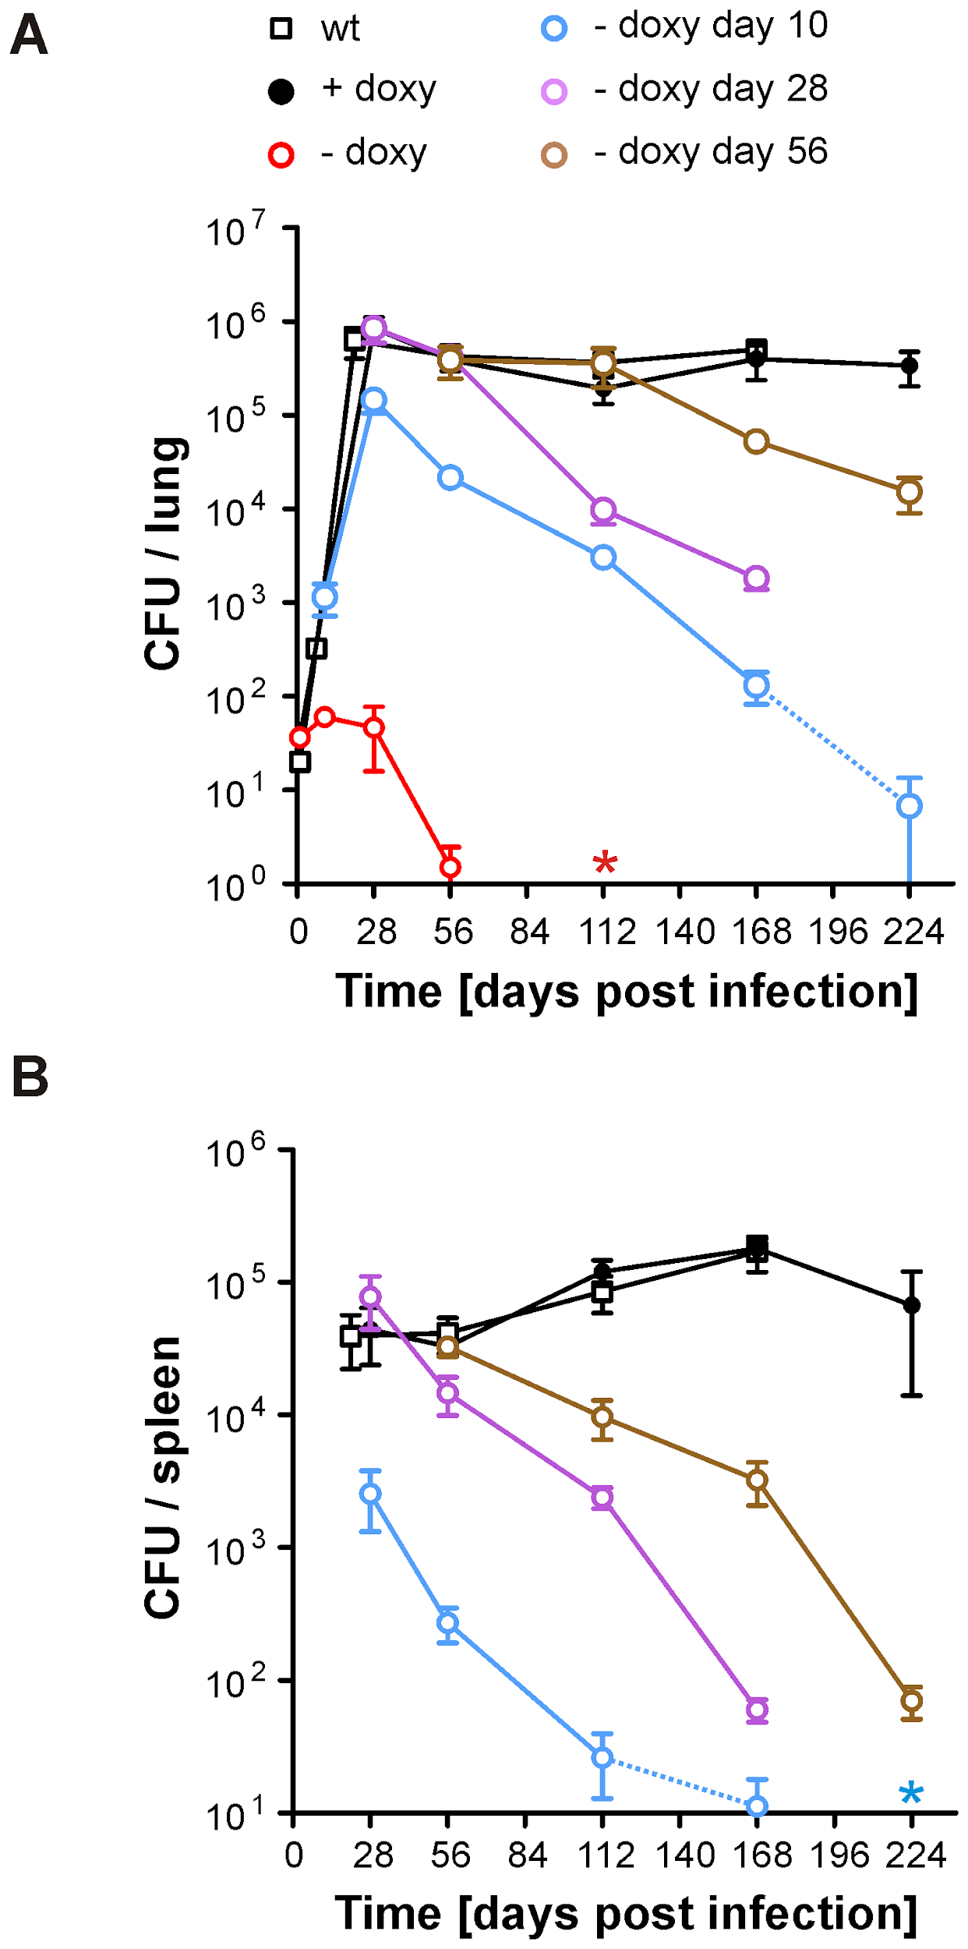
Figure 1. Growth and survival of Mtb ΔbioA TetON in mouse lungs and spleens.
(A) Growth and persistence in lungs. Squares represent data for wt, circles represent data for ΔbioA TetON. Mtb ΔbioA TetON was analyzed in mice that did not receive doxy (red circles), received doxy from day 1 to day 10 (blue circles), from day 1 to day 28 (purple circles), from day 1 to 56 (brown circles) or received doxy throughout the infection (black circles). Data are averages from at least four mice and two independent infections; error bars represent the standard error of the mean. The limit of detection was 4 CFUs per lung. Dotted lines end in data points for which most of the lungs contained 4 or fewer CFUs. The red asterisk indicates that no CFUs were recovered from any of the no-doxy mice 112 days post infection. (B) Persistence in spleens. The blue asterisk indicates that on day 224 no CFUs were recovered from any of the mice that received doxy up to day 10. Otherwise as described for (A).

Table 1. Relative BioA protein levels and activities
